Acts 2 1-2
When the day of Pentecost came, all the believers were gathered together in one place. Suddenly there was a noise from the sky which sounded like a strong wind blowing, and it filled the whole house where they were sitting.
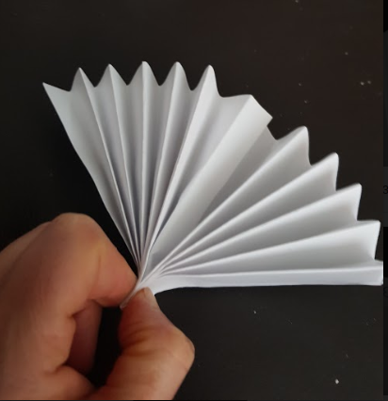
Fold the fan in half, cut the middle fold and slot the 2 middle pieces together.
Fold paper to make a fan
The Holy Spirit entered the disciple’s room like a wind. As you play with the fan ask God to help you as he helped the disciples.
Acts 2 3-4
³ Then they saw what looked like tongues of fire which spread out and touched each person there. ⁴ They were all filled with the Holy Spirit and began to talk in other languages, as the Spirit enabled them to speak.
Thread string or cotton through the holes at the bottom of the strips. Thread string or cotton through the holes at the top of the strips to make a flame shape.
Cut 3 strips of paper, 2 long, 2 medium, 2 short. Use a pencil to make a hole at the top and bottom of each strip. Colour them red, orange and yellow.
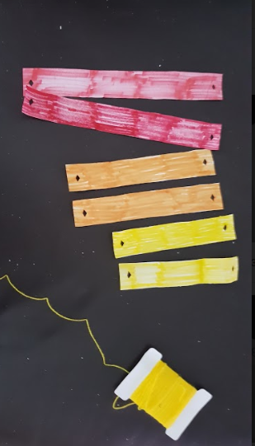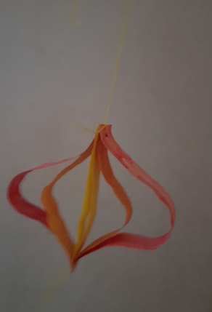

God helped the disciples to bring people together by making them speak in different languages. What skill or talent could God help you develop?

Acts 2 5-6
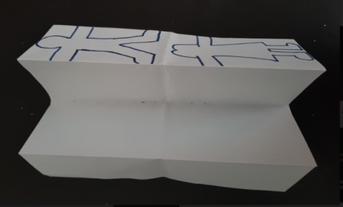
There were Jews living in Jerusalem, religious people who had come from every country in the world. When they heard this noise., a large crowd gathered. They were all excited, because all of them heard the believers talking in their own languages.
Fold paper in half and in half again. Draw a person on the front fold. Make sure the arms stretch from one end to the other and cut the person out
Unfold the paper and and you should have 4 people to decorate.
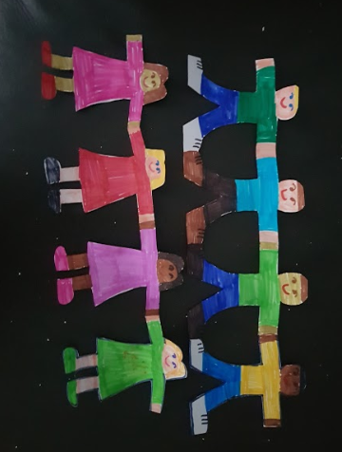

At the moment we do not live in crowds. Spend some time praying for the friends and family you can not see face to face right now.

Act 2 38-40
Peter said to them, “Each one of you must turn away from your sins and be baptized in the name of Jesus Christ, so that your sins will be forgiven; and you will receive God's gift, the Holy Spirit. For God's promise was made to you and your children, and to all who are far away—all whom the Lord our God calls to himself.”
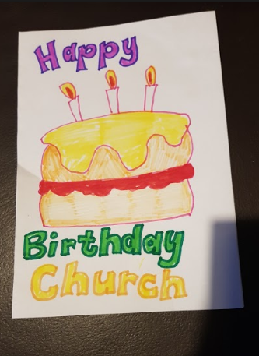
Fold a piece of paper in half. Decorate the front as a birthday card. Open the card and write a birthday message inside.
Pentecost marks the birth of the church. Spend some time thinking about why being together as a group of a believers is a good thing. What is good about our church? How could it be even better? Spend some time asking God about the role you could have in making our good church even better.
Acts 2 43 - 47
Many miracles and wonders were being done through the apostles, and everyone was filled with awe. All the believers continued together in close fellowship and shared their belongings with one another. They would sell their property and possessions, and distribute the money among all, according to what each one needed. Day after day they met as a group in the Temple, and they had their meals together in their homes, eating with glad and humble hearts, praising God, and enjoying the good will of all the people. And every day the Lord added to their group those who were being saved.
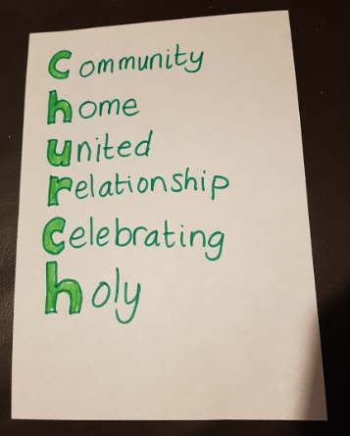
Write Church down the side of a piece of paper. Use words or sentences to explain what church should be.
The new believers worked out together what church should be, under the guidance of the disciples.
What do you think church should be? Some of your answers maybe what church is already, but maybe while we are not able to use the church building we have some time to think about how that building maybe used when it is open again. Spend some time praying and thinking about what God wants church to be.

