Doubting Thomas Craft

Making Jesus hand, to remind us that Jesus let Thomas touch His hand so that Thomas could believe that Jesus had returned.
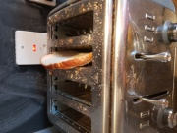 | Toast a slice of bread.
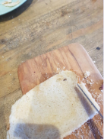 | Use a butter knife to cut off the crusts.
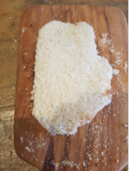 | Cut out the outline of a hand.
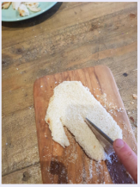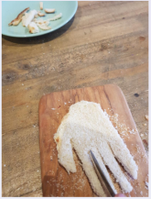 | Cut small V shapes to form the fingers.
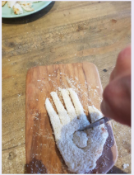 | Cut a circle out of the middle of the hand, to represent Jesus nail hole.
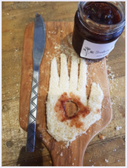 | Add some jam for added effect, if you have some.

