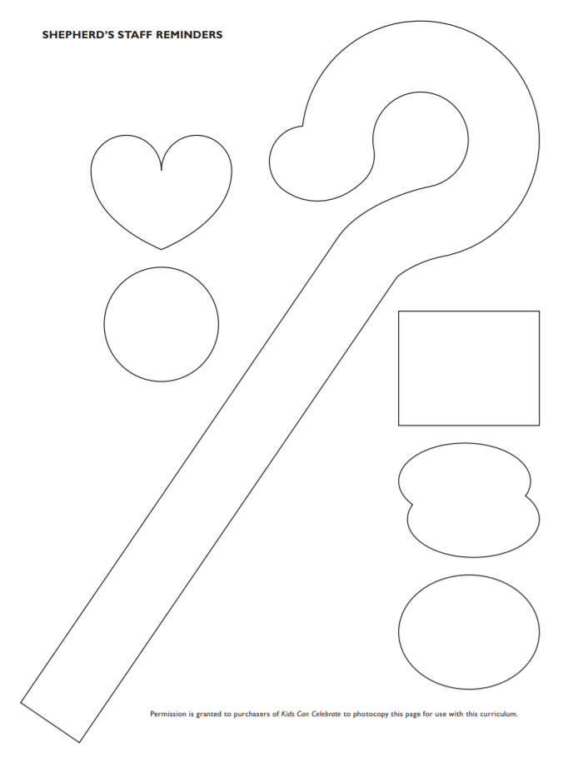 Write the following phrases on the shapes with fabric markers: (1) “The Lord is my shepherd,” (2) “I shall not want,” (3) “He makes me lie down in green pastures,” (4) “He leads me beside still waters,” (5) “He restores my soul.”
The Lord is ______ ‘s shepherd, ________ lacks nothing.
² He makes __________ lie down in green pastures,
he leads _____________ beside quiet waters,
³ he refreshes ___________’s soul.
He guides ___________ along the right paths
for his name’s sake.
⁴ Even though __________ walk’s through the darkest valley,^{[a]}
___________ will fear no evil, for you are with ____________;
your rod and your staff, they comfort ______________.

⁵ You prepare a table before ______________
in the presence of ____________’s enemies.
You anoint _____________ head with oil;
____________’s cup overflows.
⁶ Surely your goodness and love will follow ______________
all the days of ___________’s life,
and______________ will dwell in the house of the Lord Forever.

- How does writing your own name in Psalm 23 make you feel?
- What’s one thing you can do this week to remember how God loves and watches over you?

