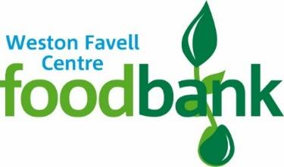
Weston Favell Centre Foodbank
c/o Emmanuel Group of Churches
Weston Favell Centre
Billing Brook Road
Northampton
NN3 8JR
Tele: 01604 402150
Email:info@westonfavellcentre.foodbank.org.uk
Date: 4th May 2020

Ref: Donation

To everyone who has donated either by local giving or direct bank transfer

Please accept our sincere gratitude for your extremely generous donations. Its individuals, groups and companies, like yourself that keep the food bank afloat. The last few weeks we’ve seen nearly two hundred parcels administered from our foodbank weekly. Which is far greater than the food donations coming in. So your very kind donation will help to bridge that gap and allow us to replenish items we need for the food parcels.

So once again it’s a huge thank you from all us at the Weston Favell Centre food bank.

Yours faithfully,

Simon Burgess

Weston Favell Centre Foodbank - Administrator

