**Sunday 29th November – Mary**

Today we learnt about Mary. She was afraid but brave and trusting when she met the Angel. Follow these instructions to hand your fears over to God like Mary did.

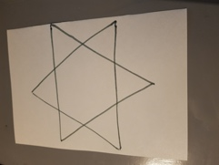

Draw a star on a piece of paper.

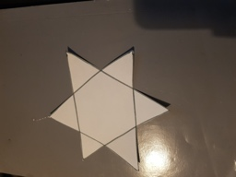

Cut it out.

Write your fear in the middle of the star.

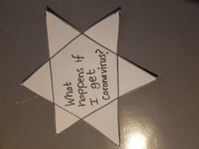

Fold the points of the star into the middle of the star.

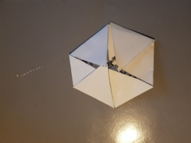

Put your star in water. The points will unfold. As they unfold image your fears being taken by God.

