Sunday 6th December – the Shepherds
Today we learnt about the Shepherds. They spotted the baby Jesus so can you play eye spy today?
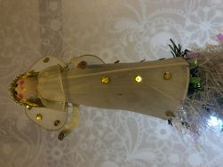
Tell the people or person you are playing with you the first sound of your thing.

Spot something.

a

Let the people or person guess your object.

?

You could play this via a video call with relatives or friends.

